Laxmi Charitable Trust’s
Sheth L.U.J College of Arts & Sir M.V. College of Science and Commerce
Department of Information Technology (B.Sc.I.T Semester V)
Applied Business Analytics
Task – 3
Roll No.: T018 | Name: Radhika Mali
Class: TYIT | Batch: 1
Date of Assignment: 14/08/26 | Date/Time of Submission: 14/08/26

Task (on house_price_regression_dataset.csv) (Don’t include in print document)
Q.1 Find the correlation between Year_Built and House_Price.
code:
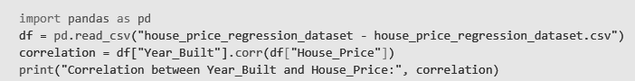
Output:

Q.2 Create a correlation matrix for all numerical columns.
Code:
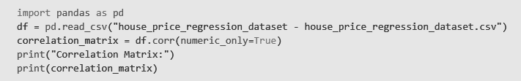
Output:
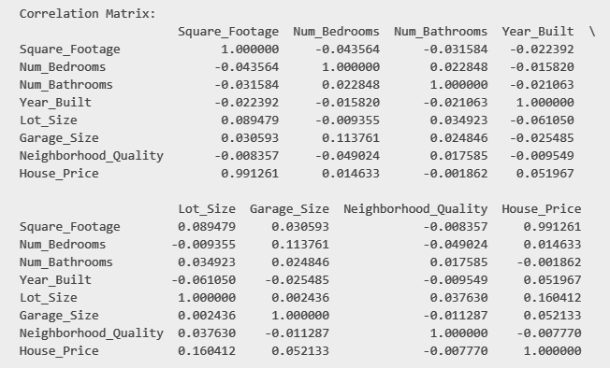

Q.3 Perform linear regression using:
X = Year_Built
Y = House_Price
Display the coefficient and intercept.
Code:
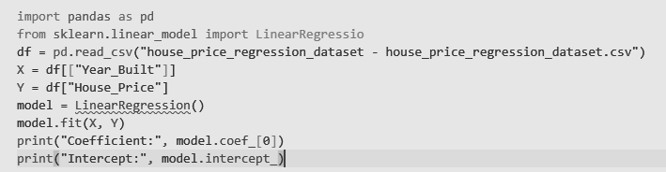
Output:
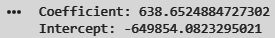

Q.4 Calculate the R2 score for the regression model:
Year_Built - House_Price
Code:
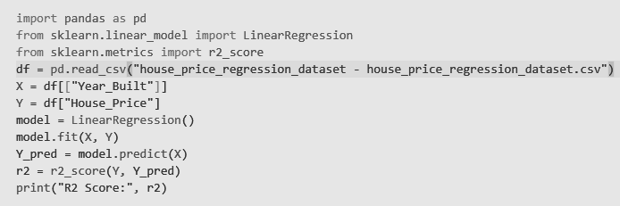
Output:

Q.5 Calculate the R2 score for:
Square_Footage - House_Price
Code:
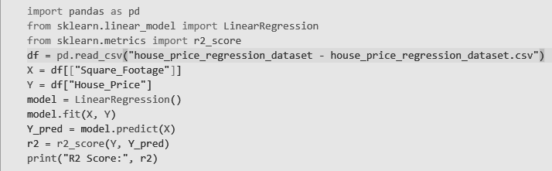
Output:

Q.6 Calculate the R2 score for:
Neighborhood_Quality - House_Price
Code:
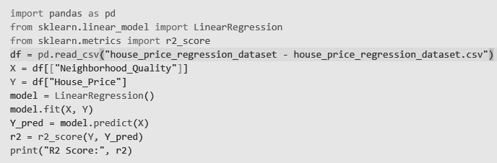
Output:

Q.7 Compare the R2 scores of all three regression models.

Regression Model | R² Score | Percentage Explained
Year_Built → House_Price | 0.0027 | 0.27%
Square_Footage → House_Price | 0.9826 | 98.26%
Neighborhood_Quality → House_Price | 0.0000604 | 0.01%

